**Brand Name : Obsession outlet**

Kids chairs

# Jaxx Julep Personalized Kids Chair - with Custom Embroidery

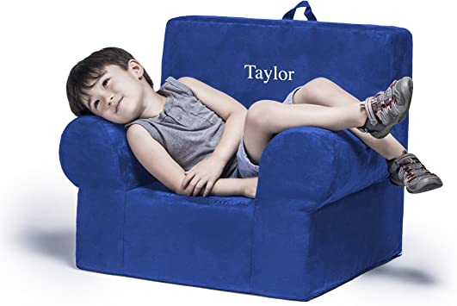**Description :**

The Jaxx Julep kids arm chair has a unique shape and design that makes it a wonderful space for kids to read and relax. You won't have to worry about rough edges because this durable, fun-sized chair is crafted from 100% lightweight, high-density foam and provides countless hours of comfort and support. Plus, it has a handle that makes it super easy for little hands to move and re-position. The microsuede cover is both removable and machine-washable so spills and stains are a breeze to clean up. This comfy padded chair delights both boys and girls by giving them a place to relax that is all their own. Each chair can be personalized with up to 10 characters.

* The Julep kids armchair has a unique shape and design that makes it a wonderful space for kids to read and relax. Includes customized embroidery - Times font lettering in white thread as shown in image, 10 characters max.
* Comfortable and sturdy foam arm chair with handle designed for kids
* Filled with safe and supportive polyurethane foam
* Personalized embroidery. Soft and durable microsuede cover is both removable and machine washable

**Rs:** **4,000**